Assignment 10.1

1. What are the names of all the countries in the databases which start with the letter "B"
(Sorted by their names)?

*use sakila;
ANS: select distinct country from sakila.country where country like 'B%' order by country;
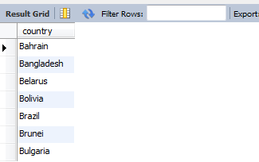
2. The first names (sorted) of all the actors with the last name "berry".
ANS: select * from sakila.actor where last_name = 'Berry' order by first_name;
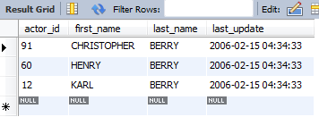
OR
select distinct first_name,last_name from sakila.actor where last_name like 'Berry%' order by first_name;
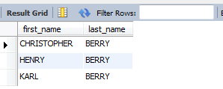

3. Find all the films whose length is more than 184 (inclusive). Order the results by the length
(and for films with the same length order them by their name). Return their title and the length.

ANS: select title,length from film where length >= 184 order by length;
